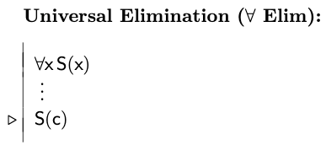

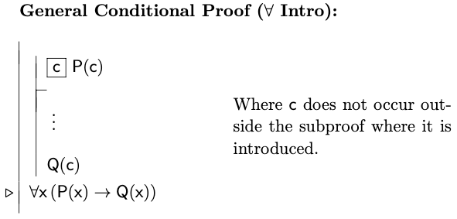

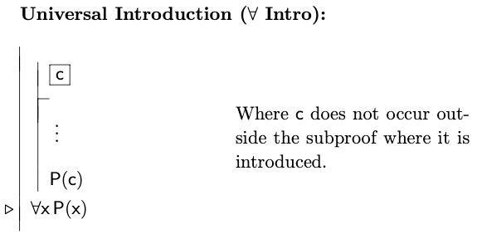

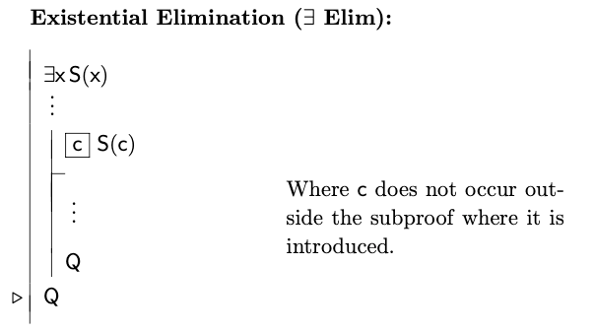

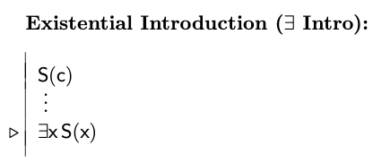

**12.1**

The third premise tells us that ∃x Slithy(x), ie some object in the domain of discourse has the property Slithy.

* **Existential Elimination:** Assume b is an object in the domain of discourse such that Slithy(b). Ie Slithy(b), by Existential Elimination.
* **| Intro:** Slithy(b) | Mimsy(b)
* **Universal Elimination**: (Slithy(b) | Mimsy(b)) *→* Tove(b).
* **Modus Ponens**: Tove(b).
* **|-Intro:** Tove(b) | Brillig(b)
* **Universal Elimination** on premise 1: (Brillig(b) | Tove(b)) *→* (Mimsy(b) & Gyre(b))
* **Modus Ponens:** Mimsy(b) & Gyre(b)
* **& Elim**: Mimsy(b).
* **& Intro**: Slithy(b) & Mimsy(b)
* **Existential Intro**: ∃x [Slithy(x) & Mimsy(x)]

**12.2**

Let b be an object in the domain of discourse.

**Universal Instantiation**

* Since b is in the domain of discourse, it has the property that   
  Brillig(b) *→* (Mimsy(b) & Slithy(b))

**General Conditional Proof**

* Let b have the property Brillig, ie Brillig(b).
* **Modus Ponens:** b has the property Mimsy and Slithy, ie Mimsy(b) & Slithy(b).
* **&-Elim:** Mimsy(b).

**GCP ∀-Intro:** ∀x Brillig(x) *→* Mimsy(x)

**Universal Instantiation**

* Since b is in the domain of discourse, it has the property that  
  ((Slithy(b) | Mimsy(b)) *→* Tove(b))

**Universal Instantiation**

* Since b is in the domain of discourse, it has the property that  
  Tove(b) *→* (Outgrabe(b,b) & Brillig(b))

**General Conditional Proof**

* Let b have the property Mimsy, ie Mimsy(b)
* **|-Intro:** Slithy(b) | Mimsy(b)
* **Modus Ponens:** Tove(b)
* **Modus Ponens:** Outgrabe(b,b) & Brillig(b)
* **&-Elim:** Brillig(b)

**GCP ∀-Intro:** ∀x (Mimsy(x) *→* Brillig(x))

⟺ **Intro:** ∀x Mimsy(x) ⟺Brillig(x)

**12.3** ∀⟺ ∃→

∃ **Elim:** Brillig(b) & Tove(b)

**& Elim:** Tove(b)

**| Intro:** Tove(b) | Mimsy(b)

∀ **Elim:** (Tove(b) | Mimsy(b)) → Slithy(b)

**Modus Ponens:** Slithy(b)

∃ **Intro:** ∃z Slithy(z)

**12.4**

∃ **Elim:** ~Large(b)

∀ **Elim:** Cube(b) → Large(b)

**Lemma (Law of Contrapositive):** ~Cube(b)

∀ **Elim:** Cube(b) | Dodec(b)

~ **Intro:** Dodec(b)

∃ **Intro:** ∃x Dodec(x)

**12.7**

∀ **Elim:** Cube(b) | Dodec(b)

∀ **Elim:** Cube(b) → (Large(b) & LeftOf(c,b)

∀ **Elim:** ~Small(b) → Tet(b)

Assume ~Small(b). Then Tet(b). Then ~(Cube(b) | Dodec(b)). Contradiction.

**~ Intro:** Small(b)

Assume (Large(b) & LeftOf(c,b)). Then Large(b). Then ~Small(b). Contradiction.

**~ Intro:** ~(Large(b) & LeftOf(c,b))

**Lemma (Contrapositive):** ~Cube(b)

Assume ~Dodec(b). Then ~Dodec(b) & ~Cube(b). Then ~(Cube(b) | Dodec(b)). Contradiction.

**~ Intro:** Dodec(b)

∃ **Intro:** ∃z Dodec(z)

**Euclid’s Theorem:** ∀x ∃y (y >= x & Prime(y))

**Domain of discourse:** all natural numbers

**Universal Introduction**

* Let n be a natural number
  + Let k be the product of all prime numbers less than n
  + Therefore, each prime less than n divides k without remainder
    - Let m = k+1
    - Then each prime less than n divides m with remainder 1.
    - Lemma: m can be factored into primes
      * Let p be one of such primes.
      * Assume p is less than n. Then p is one of the primes that are less than n, and thus it divides m with remainder 1. Thus it is not a factor of m. Contradiction.
      * **~ Intro:** p is greater than or equal to n
      * ∃ **Intro:** ∃x (Prime(x) & x >= n)
      * ∀ **Intro:** ∀n ∃x (Prime(x) & x >= n)

**12.9**

Let a be any object in the domain.

Then a is either a large cube or a small tetrahedron, by universal elimination.

If a is a large cube, then ~Small(a), so Small(a) -> BackOf(a,c).

If a is a small tetrahedron, then a is a tetrahedron. By universal elimination, Tet(a) -> BackOf(a,c).

By -> Elim, BackOf(a,c)

Therefore Small(a) -> BackOf(a,c)

By Disjunction Elim, we have our result.

**12.16** ∀⟺ ∃→

We will prove the desired conclusion using proof by contradiction.

Assume the negation of the conclusion: there exist cubes x and y such that x is to the right of y.

We will use the method of existential elimination. The assumption for this subproof method is that there are cubes c1 and c2 such that c1 is to the right of c2.

By premise 2, both cubes are small.

By premise 4 one is not larger than the other.

From our existential elimination assumption, we can infer that c1 is to the right of c2.

From the meaning of the predicates, this means c2 is to the left of c1.

From premise 1, this means c2 is larger than c1, contradicting our statement above that c2 is not larger than c1.

We have a contradiction.

By existential elimination, we can infer contradiction, since this contradiction is reached for any cubes satisfying the initial assumption, and we are in the subproof that uses that assumption.

But then, we have a contradiction within the subproof by contradiction.

By negation introduction we conclude the negation of the negation of our desired conclusion, therefore we can infer our desired conclusion: there do not exist cubes x and y such that x is to the right of y.

**12.13**

∀x (GreatActor(x) -> (AdmiredByH(x) -> ~AdmiresSelf(x)))

∀x ((GreatActor(x) & ~AdmiresSelf(x)) -> AdmiredByH(x))

**Conclusion:** ~GreatActor(H)

**Proof:**

**∀ Elim:** GreatActor(H) -> (AdmiredByH(H) -> ~AdmiresSelf(H))

**∀ Elim:** (GreatActor(H) & ~AdmiresSelf(H)) -> AdmiredByH(H)

**Contradiction Assumption:** GreatActor(H)

AdmiresSelf(H) | ~AdmiresSelf(H)

**Case 1: AdmiresSelf(H)**

* **Taut Con:** AdmiredByH(H)
* **& Intro:** GreatActor(H) & AdmiresSelf(H)
* **-> Elim:** AdmiredByH(H) -> ~AdmiresSelf(H)
* **Lemma (Contrapositive Law):** ~AdmiredByH(H)
* **Contradiction**

**Case 2: ~AdmiresSelf(H)**

* **Taut Con:** ~AdmiredByH(H)
* **-> Elim:** AdmiredByH(H)
* **Contradiction**

**| Elim:** Contradiction

**~ Intro: ~GreatActor(H)**

**12.14**

There is an incorrect step in this proof. A universal elimination assumption was used that c is one of the objects in the domain. Then it was assumed that d is some other object that is specifically different from c. This choice of d is specific to the object c. If we were to choose another object in place of c, it wouldn’t necessarily be the case that it is different from d. We cannot generalize the fact that d is different from c, to any object in place of c.

**12.28**